MIGOTO

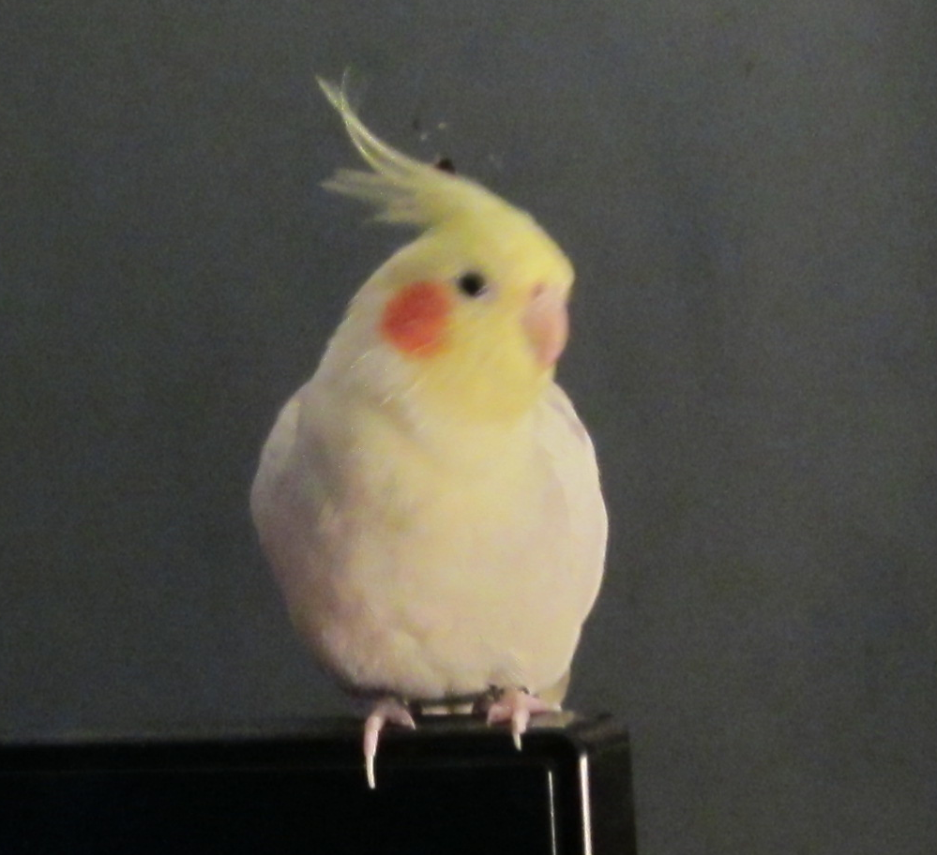

Lost May 1st in Auburndale(Newton) Mass

About 7 years old

Owner: Paul Ranelli

Contact: 978-985-9081

ranelli5@comcast.net