LOST

If you have ANY information leading to us finding our

“LITTLE GUY”

7 1/2 years old is STILL MISSING from DOUGLAS, MA
since May 21st 2011
PLEASE Contact paw0214@hotmail.com

He might come if you say “Wanta go see Grandpa?”
Or if you say… “Little Guy, want some yummies?” (cracker or whatever).
If sighted please call immediately 781-526-5470 for further ideas on capture.
Thank you so much for your “Eyes to the Skies” for our little one.

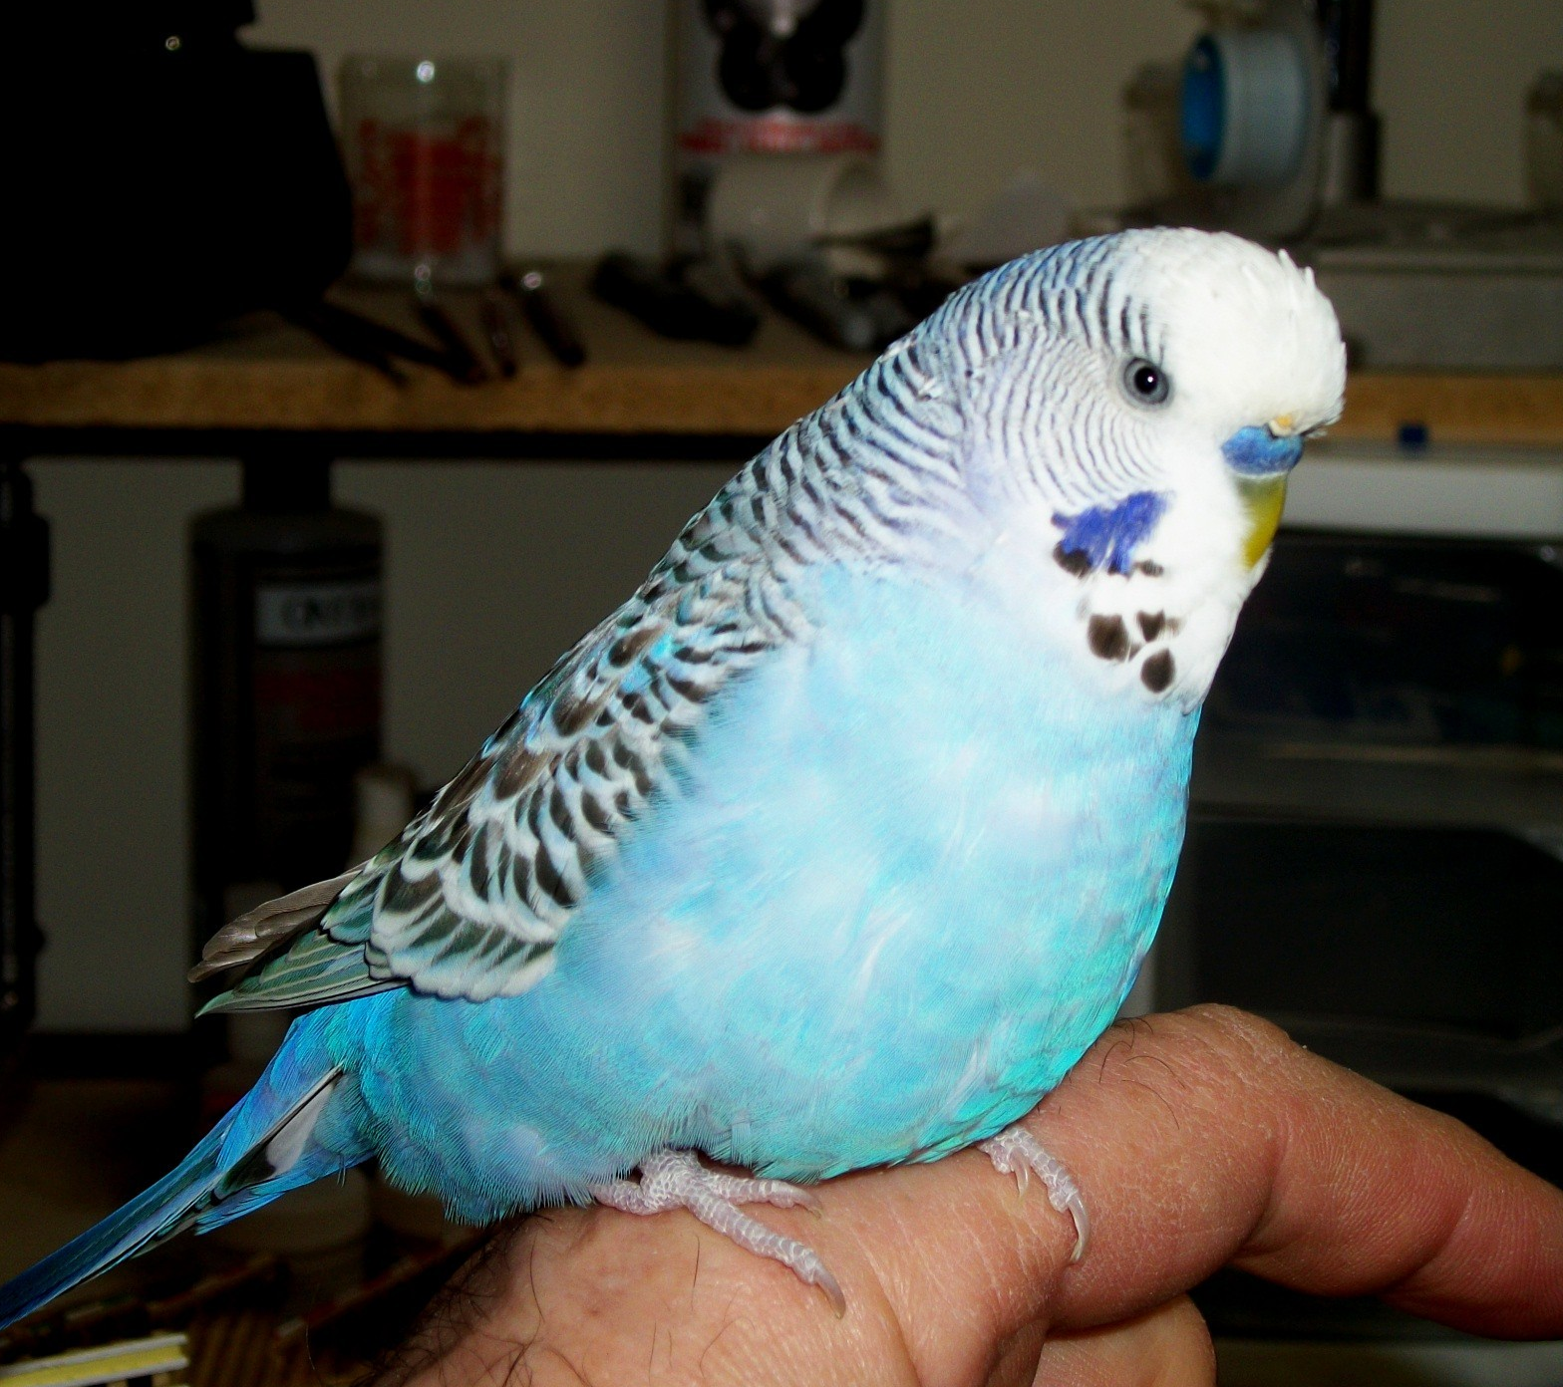

.
If you think you found “Little Guy” last year and recognize above actions, there will be a handsome reward for his return. He is a sorely missed family member to this day.

